MS Access
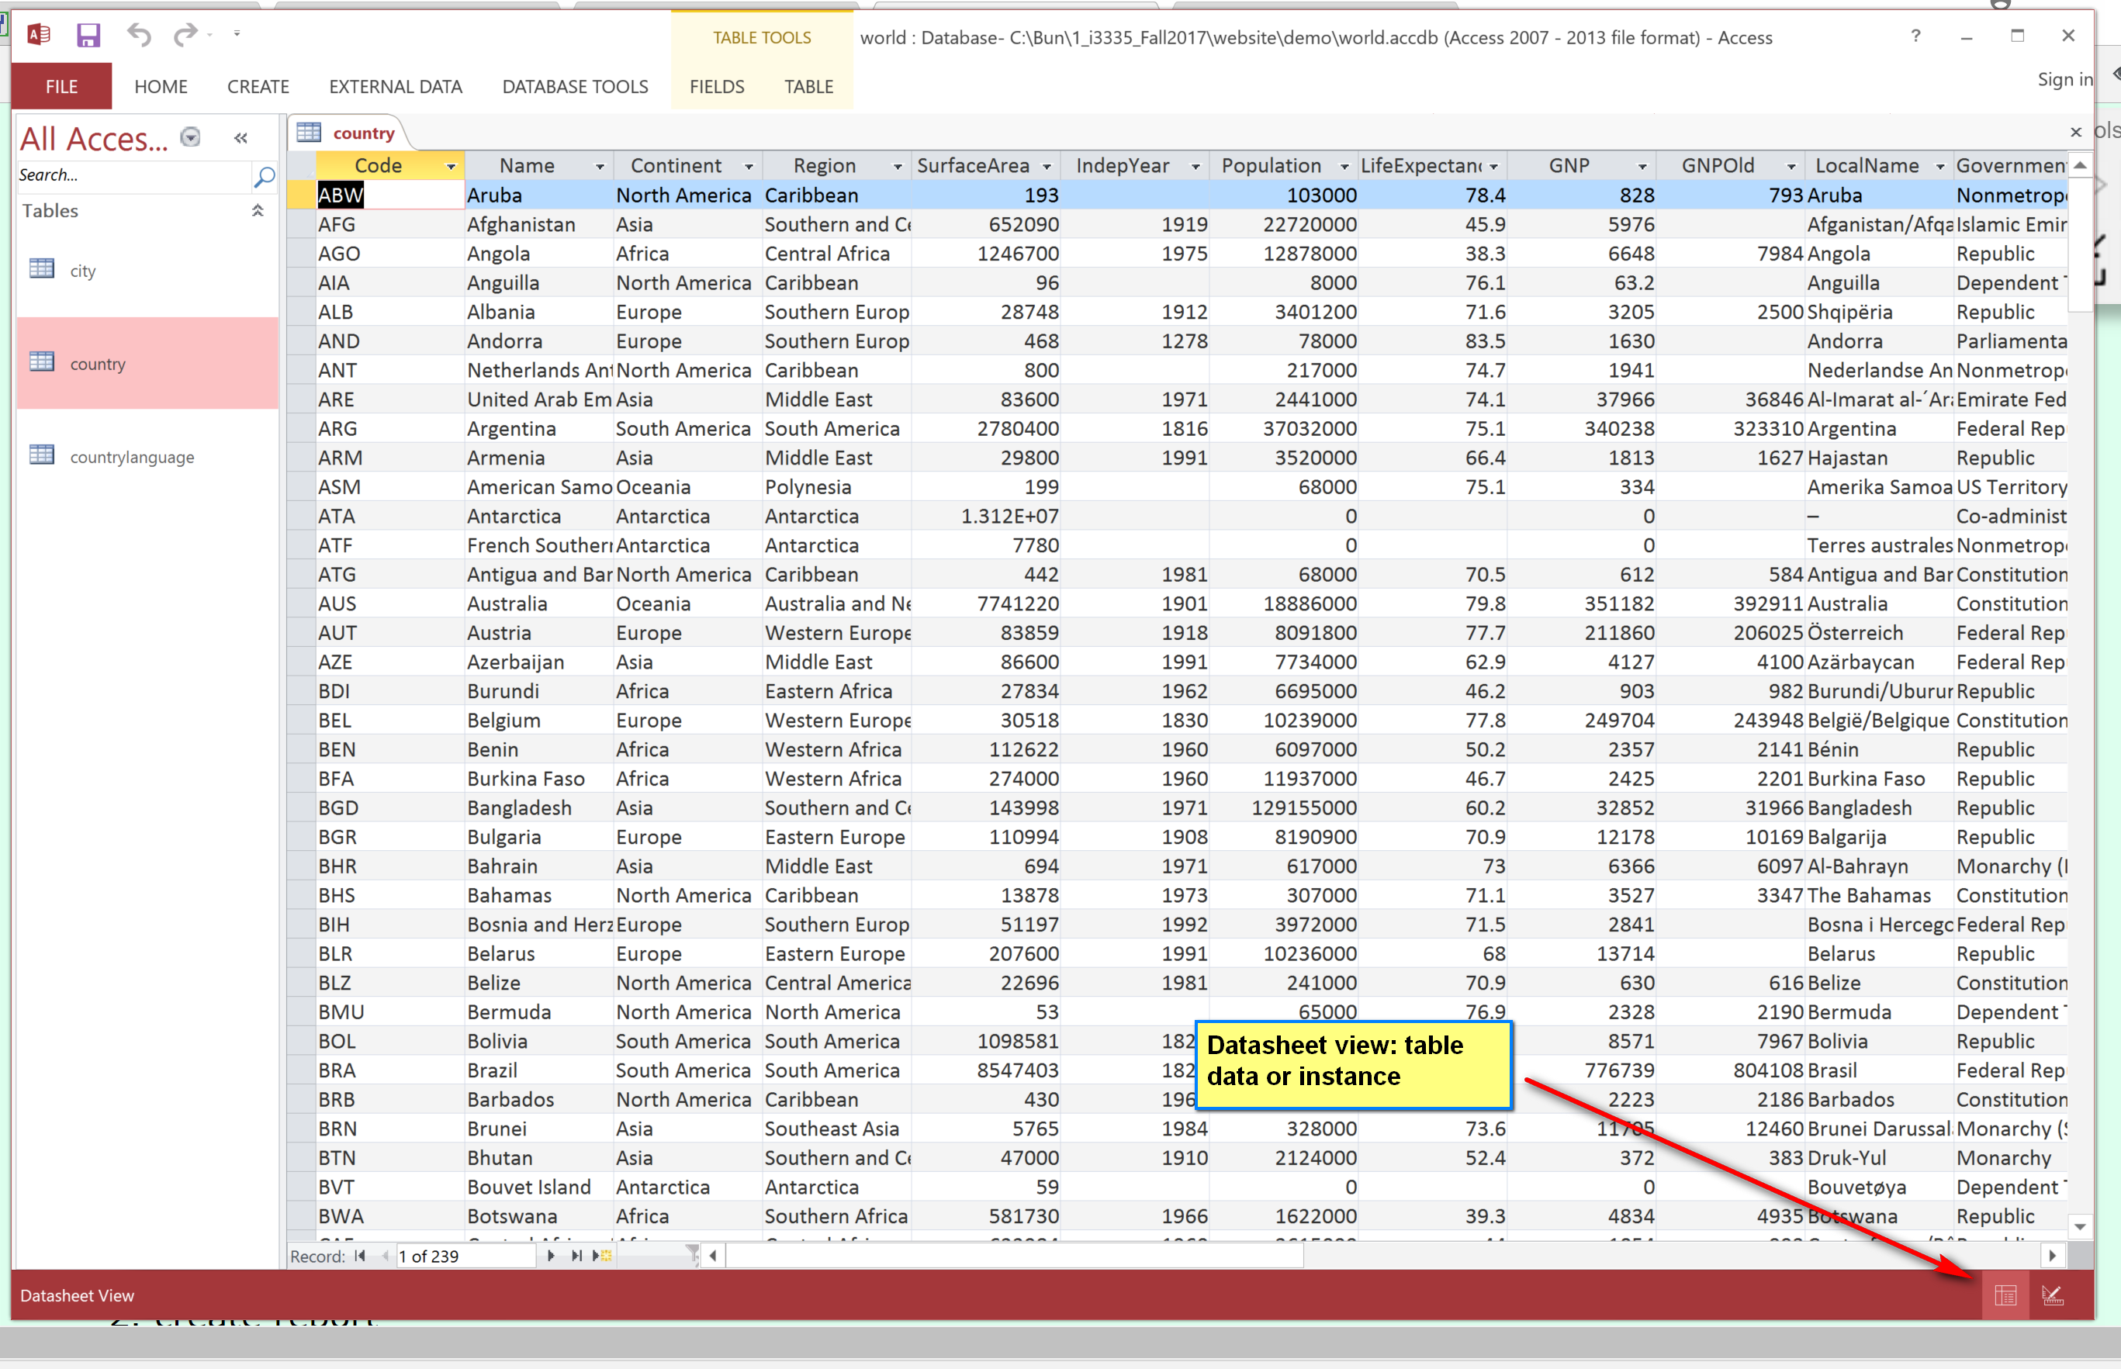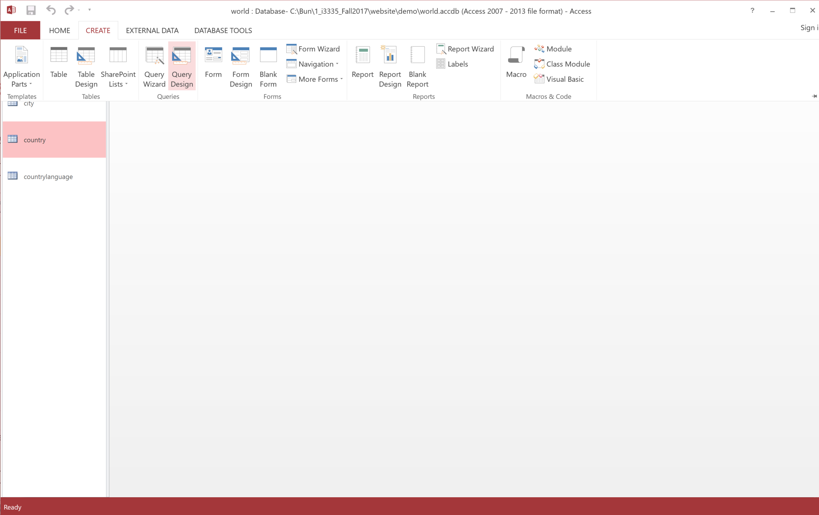
Query:

Code, name, GNP and life expectancy of countries where life >= 70.
- 4 columns in the country table.
- Select the country table in the Query Design Tool.
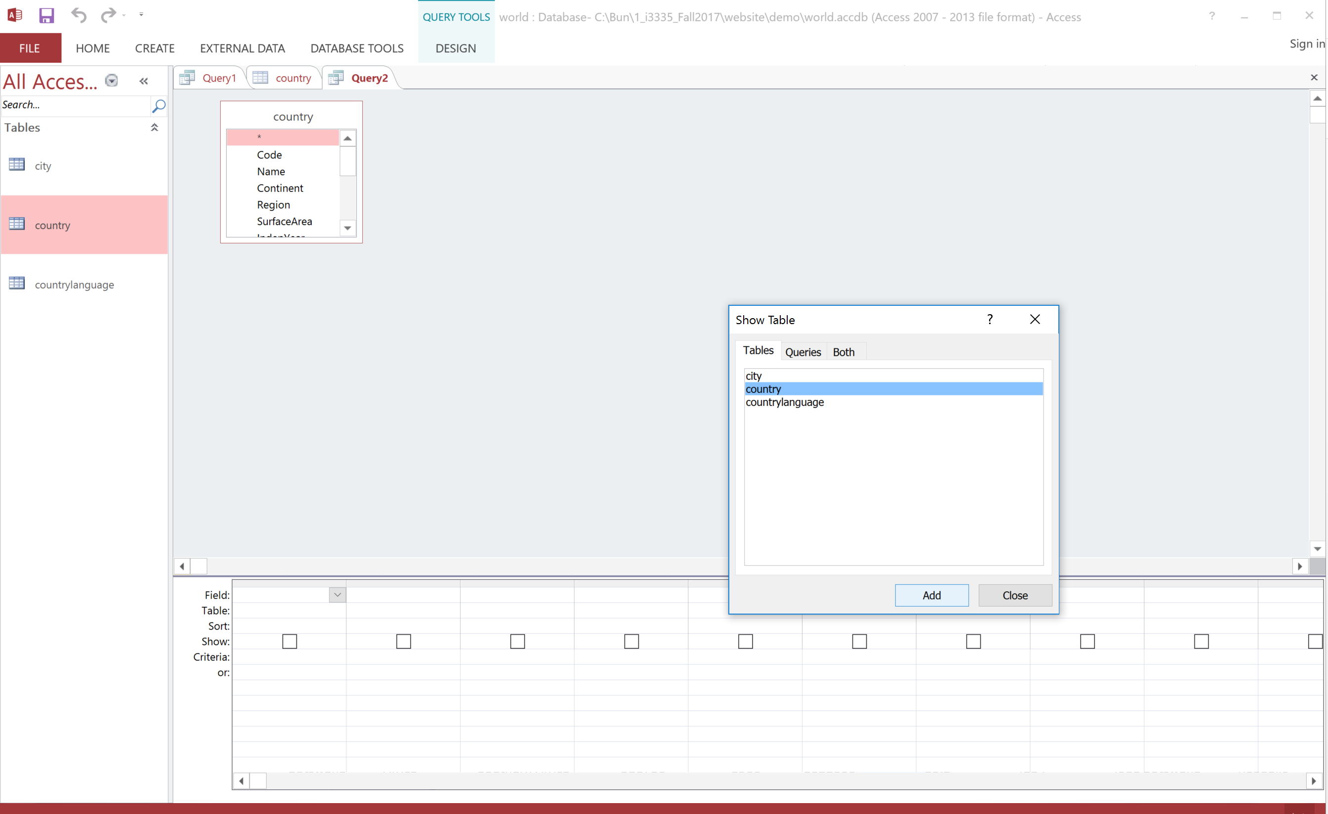
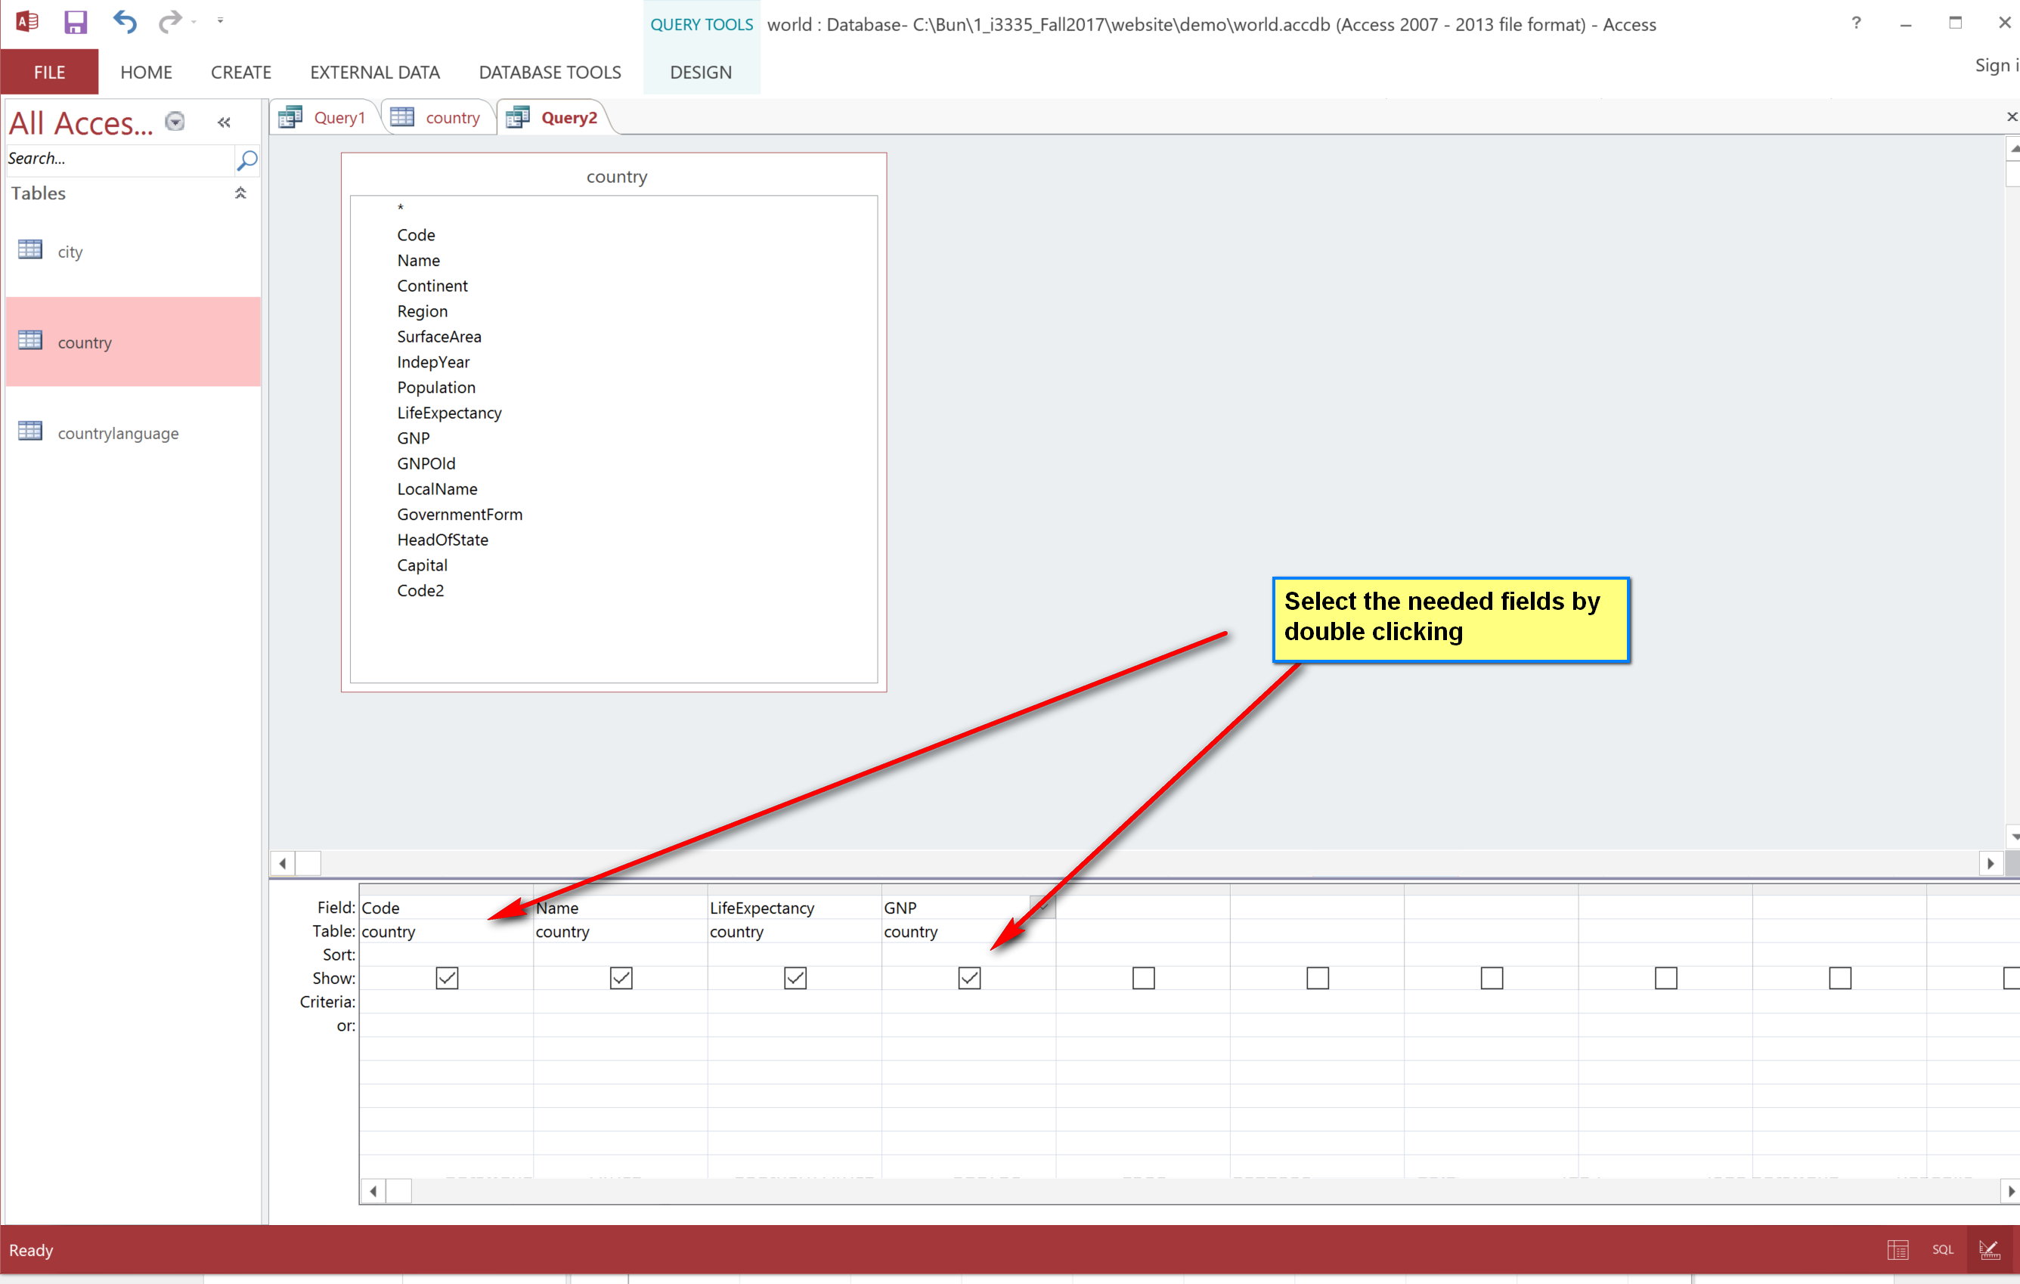

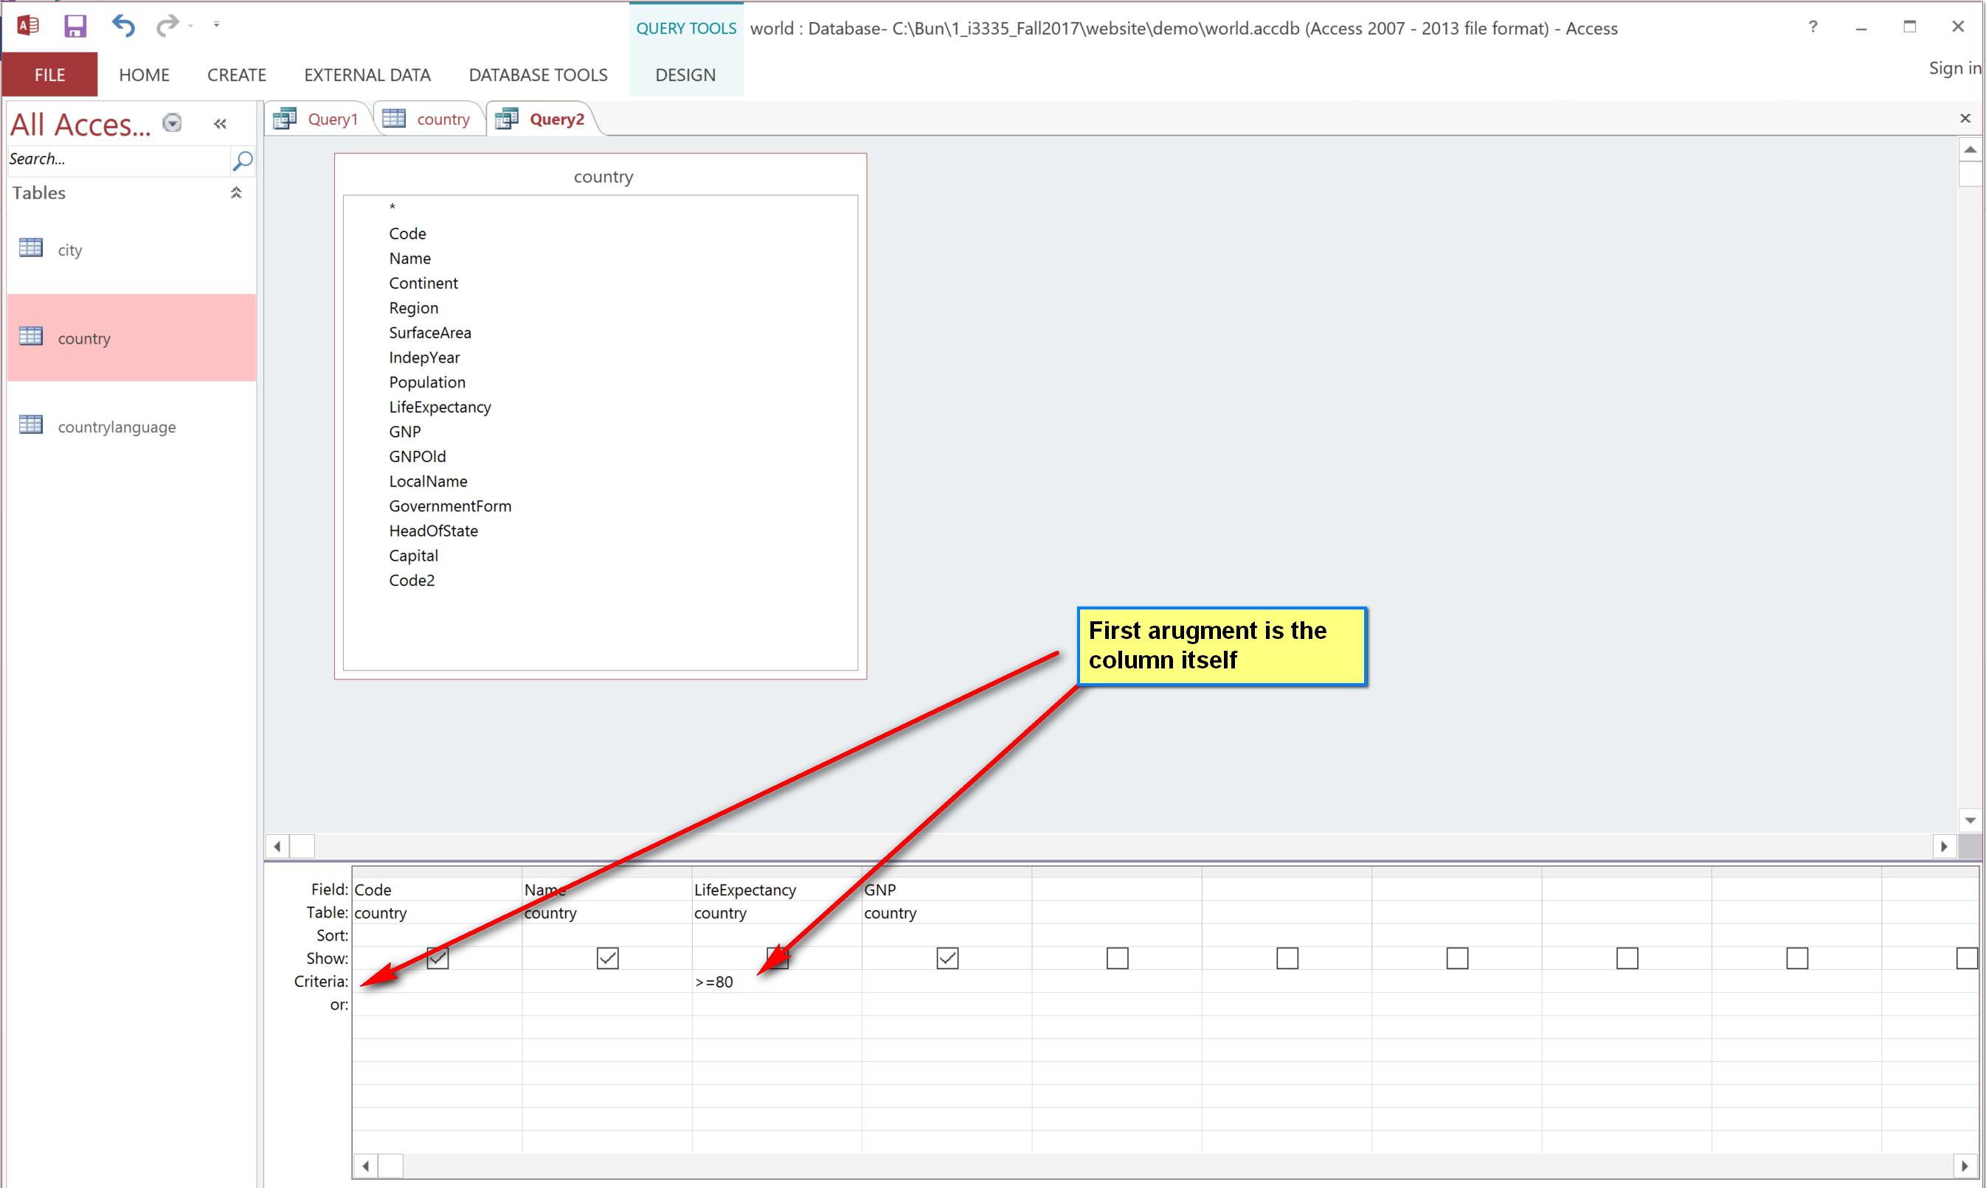

Query: city names (with city population more than 5000000), country names and language names.
- Need all three tables: city, country and language.
World database’s PK:
- Country: countryCode (PK)
- City: Id (PK)
- Countrylanguage: PK: {countryCode, language}
Foreign key (FK):
- City: countrycode references Country(code). (Code is the PK of Country)
- Countrylanguage: countrycode references Country(code). (Code is the PK of Country)
